

**CSE 240 Data Science with R**

**STUDENT WORK BOOK**

|  |  |  |
| --- | --- | --- |
| **Name** | **:** | M SIVANT |
| **Unique ID** | **:** | E00119004 |
| **Year** | **:** | II |
| **Quarter** | **:** | Q6 |
| **Department** | **:** | B.Tech CSE (CyS & IoT or AI &ML) |
| **Faculty Name** | **:** | Prof.B.Nirmala or Prof.N.Chiranjeevi |
| **Academic Year** | **:** | 2020-2021 |

**Date: 10-11-2020**

**Questions:**

1. The coin is flipped ten times. Find the probability of 7 heads occurring.
2. A card is selected three times (and replaced). Find the probability of 2 face cards occurring.
3. 3. A student decides to guess on a section of his ACT test. The section contains 50 multiple choice questions and each question has 5 possible answers.
   1. Find the expected number of correct responses.
4. A company ships 5000 cell phones. They are expected to last an average of 10,000 hours before needing repair; with a standard deviation of 500 hours. Assume the survival time of the phones are normally distributed. If a phone is randomly selected to be tracked for repairs find the expected number that needs repair,
   1. after 11,000 hours

**Program:**

# question 1

print(dbinom(7,size=10,prob=0.5)*100)

# question 2

print(dbinom(2,size=3,prob=(3/13))*100)

# val = 3*((3/13)^2)*((10/13)^1) # using formula

# question 3

n = 50  # (no of questions)

p = 0.2 # probability for answer is right

# number of correct responses

print(n*p)

# question 4

# number of phones that need repairs

p_pval = pnorm(11000,mean=10000,sd=500,lower.tail=FALSE)

num_phones = round(p_pval * 10000)

print(num_phones)

**Output:**

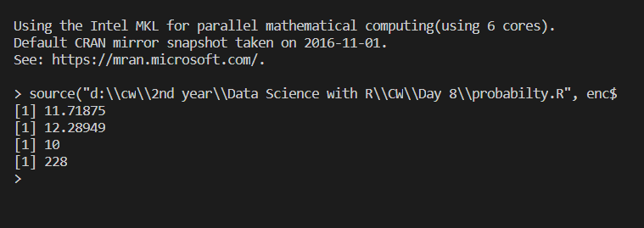

**Explanation:**

1. Binomial distribution:

The binomial distribution is a discrete probability distribution.

      (    )
        n    x      (n− x)
f(x) =  x   p (1− p)      where x = 0,1,2,...,n


**Syntax:**

Discrete : dbinom(no of occurance event ,no. of trails, probility of the event)

Continuous : pbinom(no of occurance event ,no. of trails, probility of the event)

**Note:**

pbinorm gives summation of probability till n events where as dbinom gives the probability of nth event

1. Normal distribution:

The normal distribution is defined by the following probability density function, where μ is the population mean and σ2 is the variance.

**Syntax:** pnorm(value, mean, sd, lower.tail=FALSE)